**Ranking System**

**Ranking system :**

1. The ranking system is only used for the freelancer.
2. The freelancer is always in ranking system even he subcribe a package or not.
3. The ranking system will use rank points to arrange the order of the freelancer.
4. The rank should be unique, if there are two the freelancer have the same rank points, the freelancer get the rank point sooner will get the higher rank.
5. The freelancer can get rank points when they complete one of these actions :

* Get rating score of reviews ( meet the condition in admin dashboard )
* Reach the number of reviews ( meet the condition in admin dashboard )
* Reach the number of the notifications ( meet the conditioin in admin dashboard )
* Subcribe packages of the freelancer ( meet the conditioin in admin dashboard )

1. Add the rank to the freelancer’s profile page and the profile section like this :

**(** will discuss and change the color, the position , the appearance later )

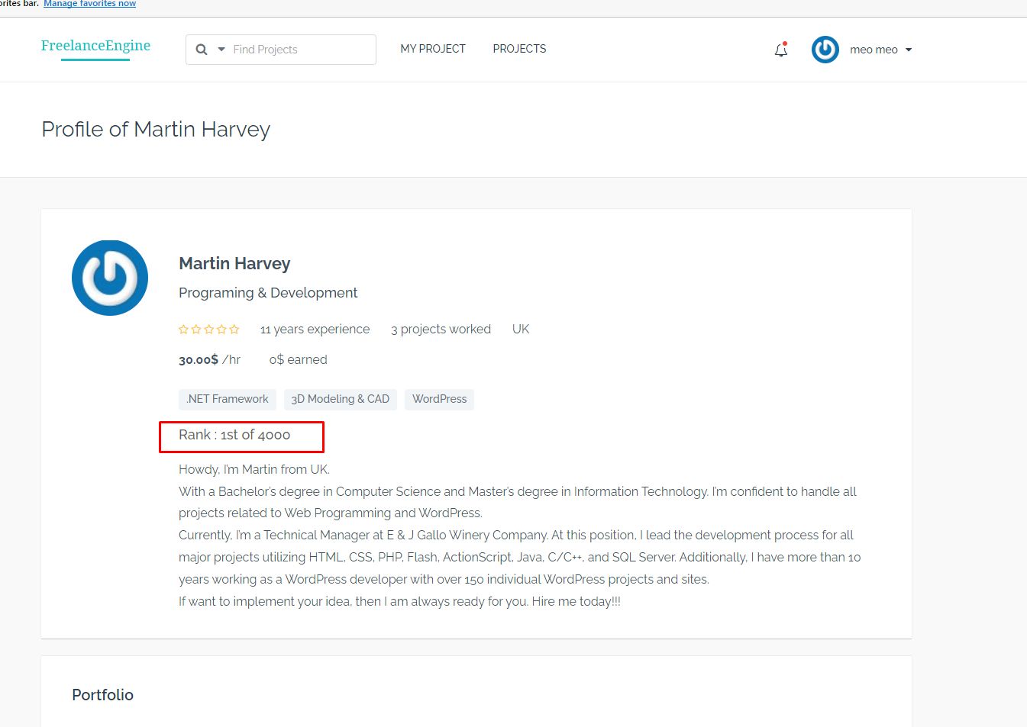

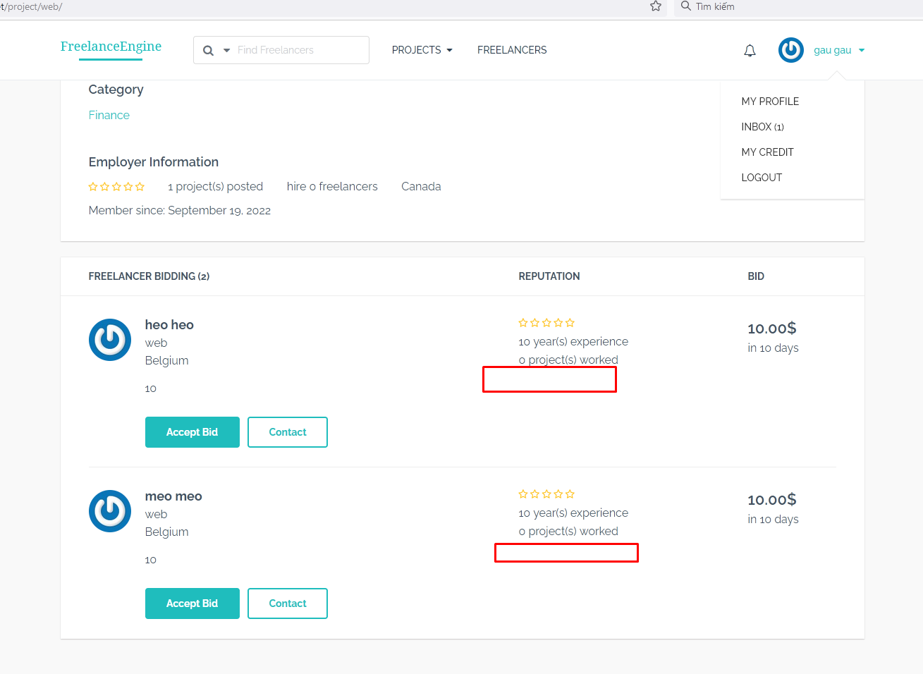

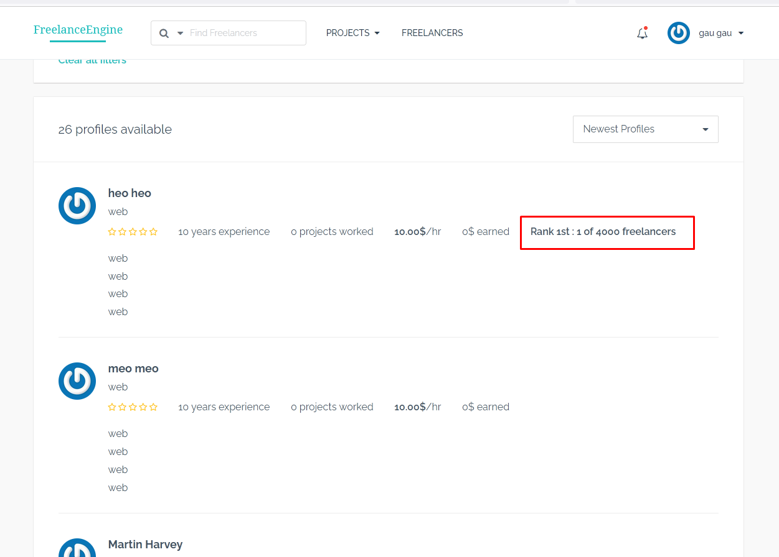

1. Set top rank as default filter option for the freelancer search result page and sort the freelancer by top rank.

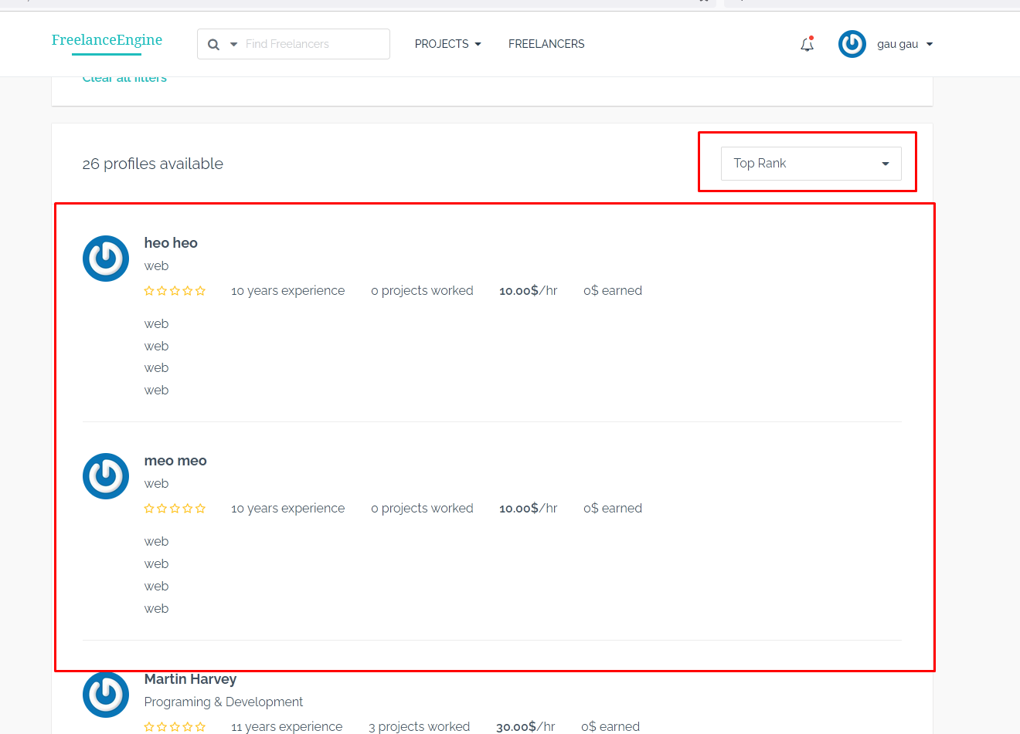

**Admin dashboard :**

* **The rating of reviews :**
  + Rank Points : 10
  + Condition : get 5 rate score of the reviews.
* **The number of reviews :** 
  + Rank Points : 10
  + Condition : get 1 reviews after finish the project
* **The number of notification**
  + Rank points : 20
  + Condition : create a new notification
* **The subcription :** 
  + Rank points : 25
  + Condition : subcribe the standard or pro …. ( admin can set this ).

Create a rank table in admin dashboard :

For example :

|  |  |  |
| --- | --- | --- |
| Users | Rank Point | Rank |
| Tom | 125 | 1st |
| Mary | 70 | 2nd |
| Ken | 40 | 3rd |